mohan raj:

**Without using library for finding prime numbers, write a PYTHON script and print all the prime numbers between 0 and N where N is input parameter and will be given by you at each time of your run. Hence, find the second largest prime number form your list and print it.** 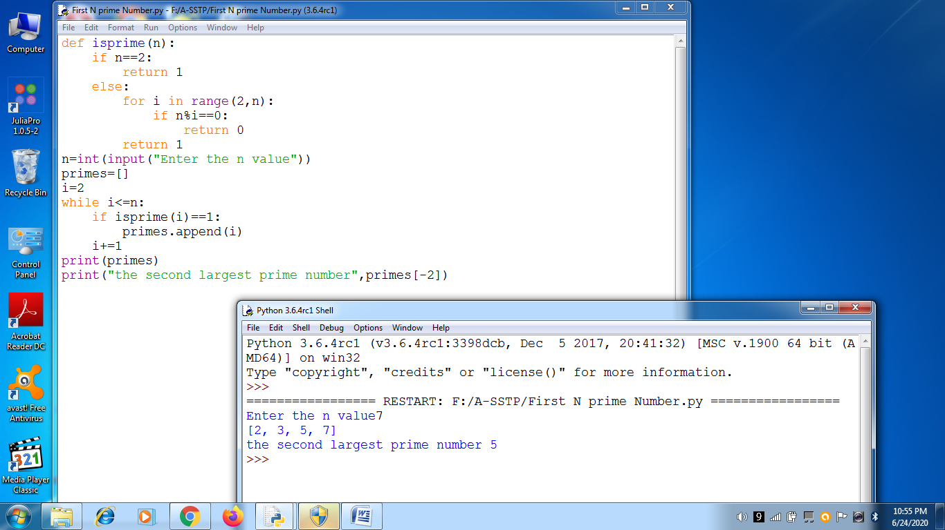

def isprime(n):

if n==2:

return 1

else:

for i in range(2,n):

if n%i==0:

return 0

return 1

n=int(input("Enter the n value"))

primes=[]

i=2

while i<=n:

if isprime(i)==1:

primes.append(i)

i+=1

print(primes)

print("the second largest prime number",primes[-2])